**Q1:(a) Create Table Employee with 6 columns that is employeeid, employeename, gender, managerid, salary, deptno.**

**Ans:** create table Employee(employeeid smallint, employeename varchar(15),

gender char(2), managerid smallint,

salary smallmoney, deptno smallint);

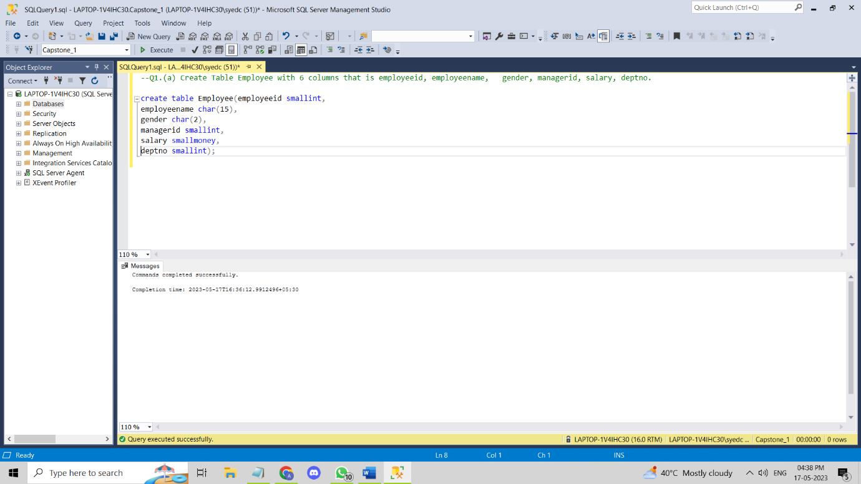

**Q1:(b) Create table department with 3 columns deptno, deptname, city.**

**Ans:** create table Department(deptno smallint, deptname char(15), city char(20));

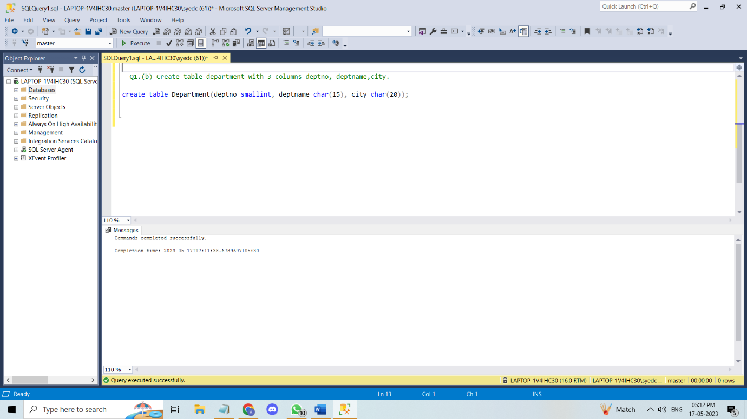

**Q2: add email column in employee table, and change column name city to location in department table.**

**Ans:** alter table Employee add email varchar(25);

exec sp_rename 'Department.city', 'Location', 'COLUMN';

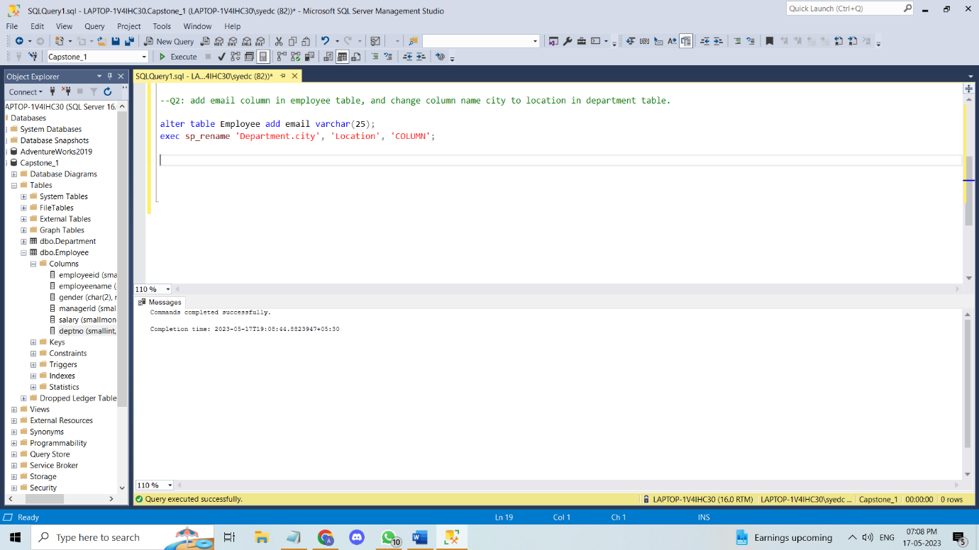

**Q3: Add following constraints in employee and department table:-**

**(a)add primary key to employeeid**

**Ans:** Alter table Employee alter column employeeid smallint Not null;

--(Here, I alter the column employeeid to Not null to make it a primary key)

Alter table Employee add Primary key(employeeid);

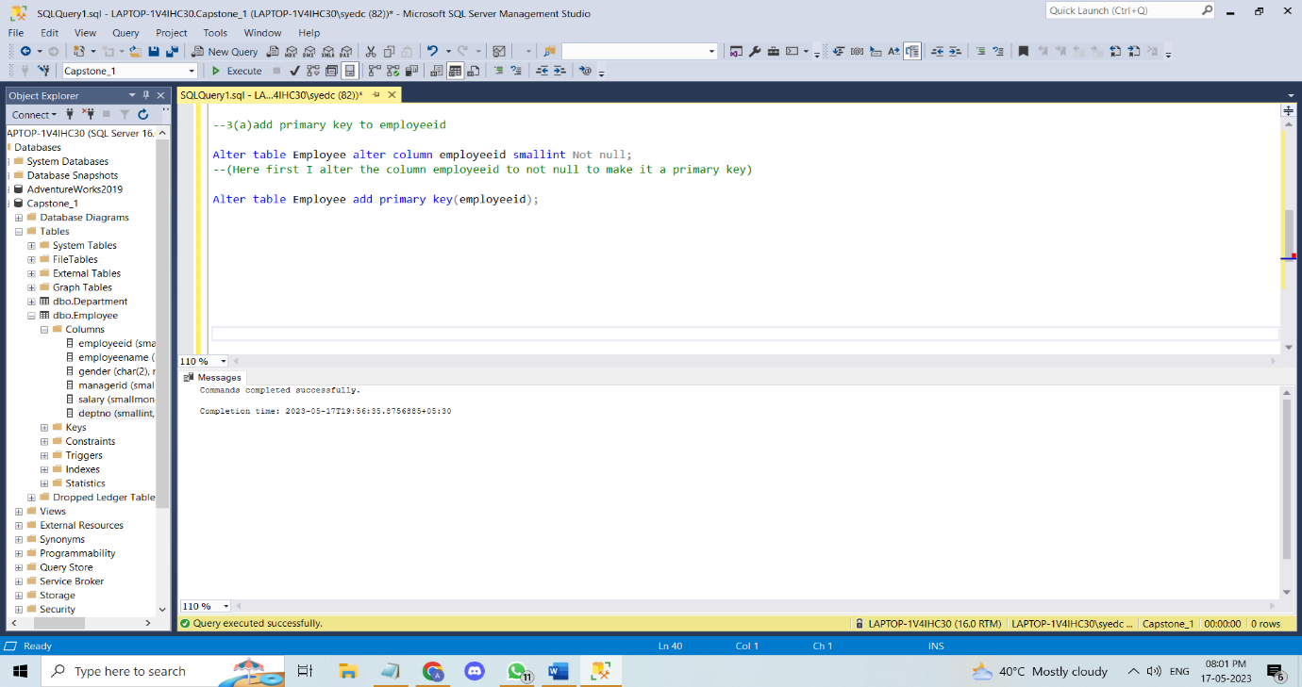

**(b)** **add primary key to department table in department table.**

**Ans:** Alter table Department alter column deptno smallint Not Null;

--(Here, I alter the column deptno to Not Null to make it a primary key)

Alter table Department add Primary key(deptno);

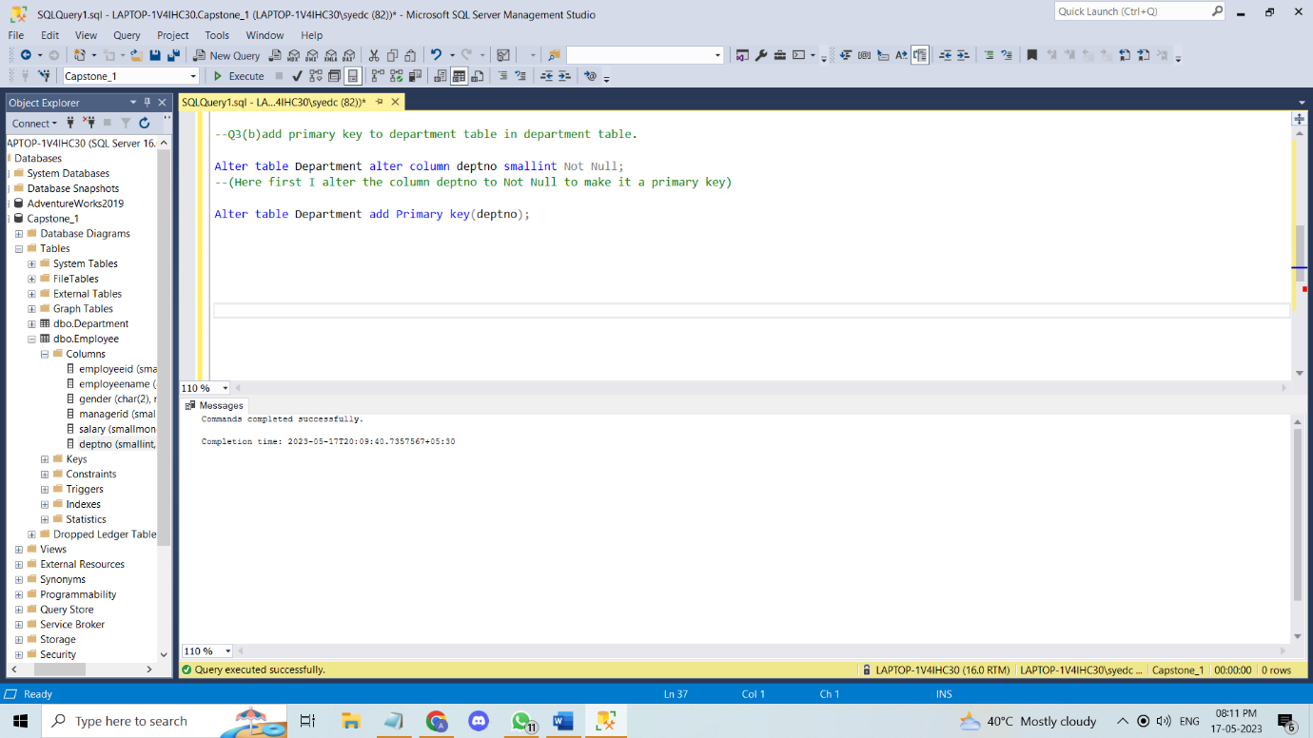

**(c)** **Add foreign key to deptno in employee table referencing deptno in department table.**

**Ans:** Alter table Employee alter column deptno smallint;

--(Here I alter the column deptno to Not Null to make it a foreign key)

Alter table Employee add Foreign key(deptno) references Department(deptno);

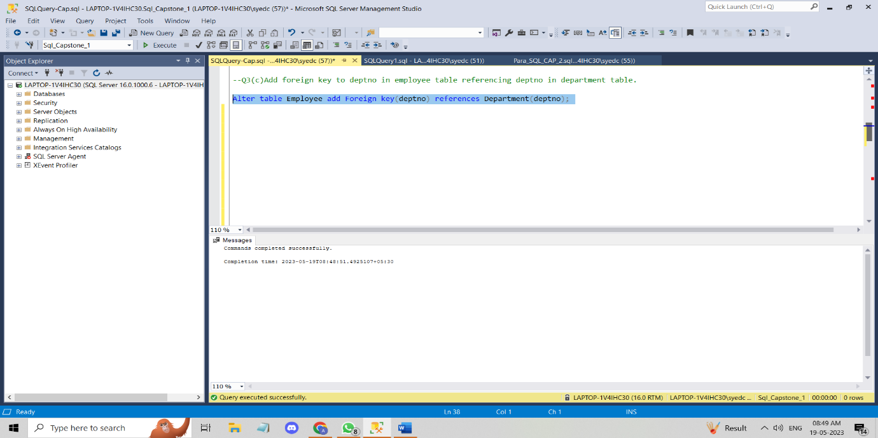

**(d) Add foreign key to manager id in employee table referencing employeeid**

**Ans:** Alter table Employee alter column managerid smallint Not Null;

--(Here I alter the column managerid to Not Null to make it a foreign key)

Alter table Employee add Foreign key(managerid) references Employee(employeeid);

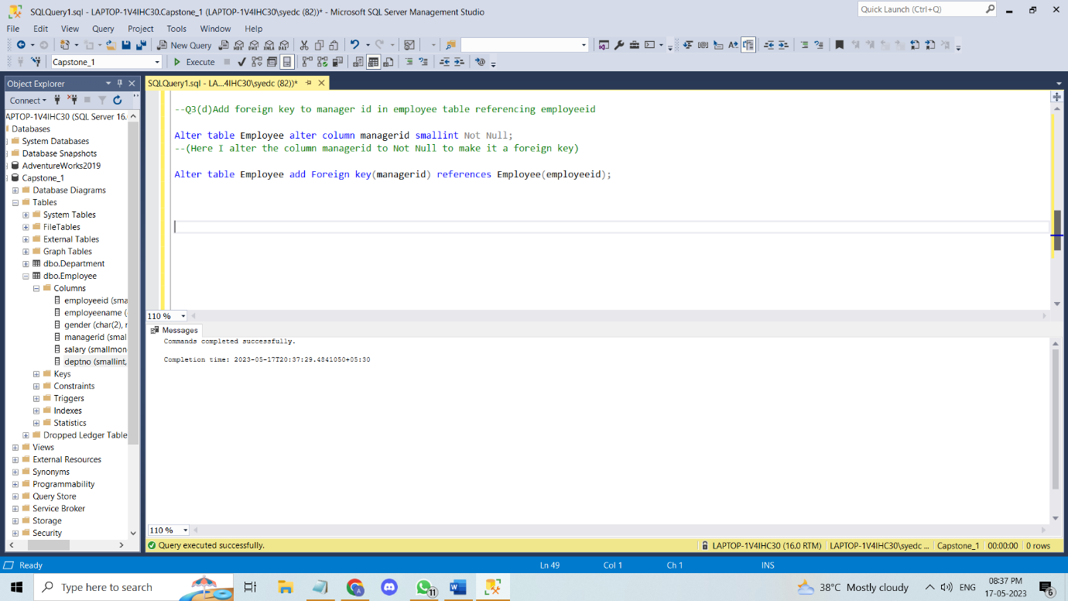

**(e) Add default constraint to email column where default value is ‘na’.**

**Ans:** Alter table Employee add constraint Emp_email default 'na' for email;

update employee set email = 'na' where email is null;

select * from Employee

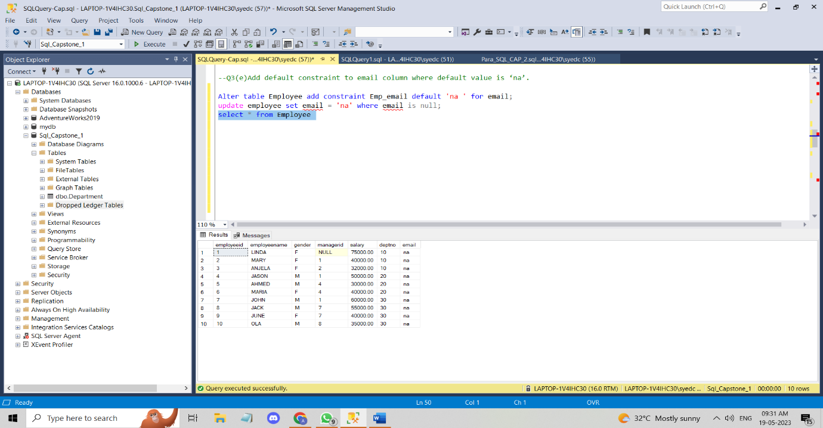

**(f) Add check constraint to city column that, city can be from Noida,delhi and lucknow only.**

**Ans:** Alter table Department add constraint check_city check(Location in

('Noida','Delhi','Lucknow'));

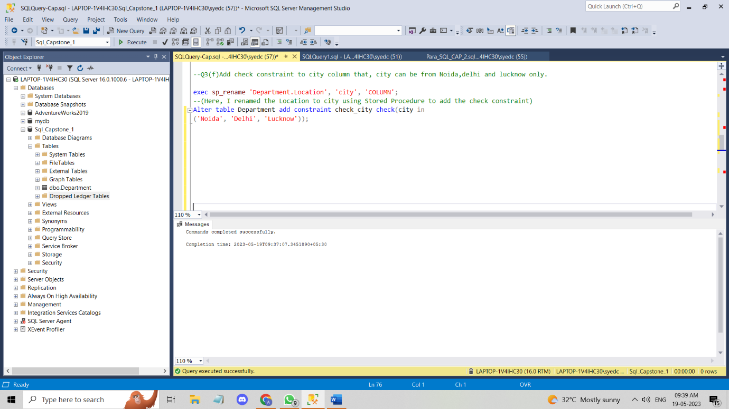

**(g) Add check constraint to salary column, that non negative salary value are not possible.**

**Ans:** Alter table Employee add constraint check_salaey check(salary > 0);

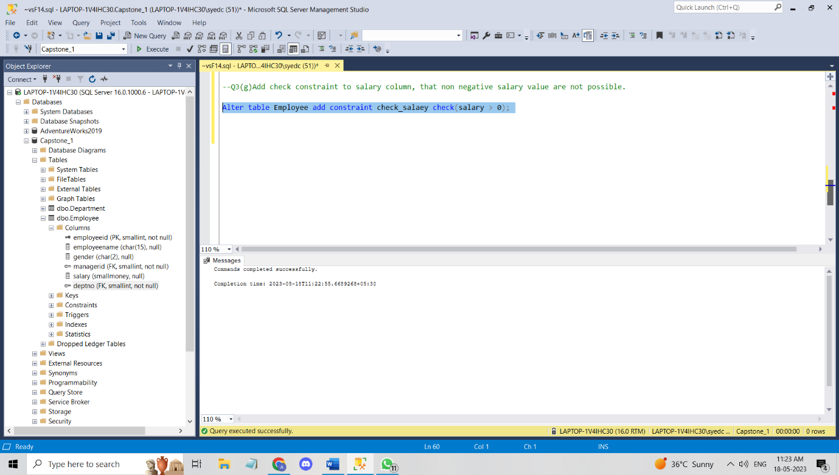

**(4) write insert command to insert the given data into both the tables.**

**Ans:** insert into Employee(employeeid, employeename, gender, deptno, salary, managerid)values

(1,'LINDA','F',10,75000,null),(2, 'MARY','F',10,40000, 1),

(3, 'ANJELA', 'F',10,32000, 2),(4, 'JASON', 'M',20,50000,1),

(5, 'AHMED', 'M',20,30000,4),(6,'MARIA','F',20,40000,4),

(7, 'JOHN', 'M',30,60000,1),(8, 'JACK','M',30,55000,7),

(9,'JUNE','F',30,40000,7),(10,'OLA','M',30,35000,8);

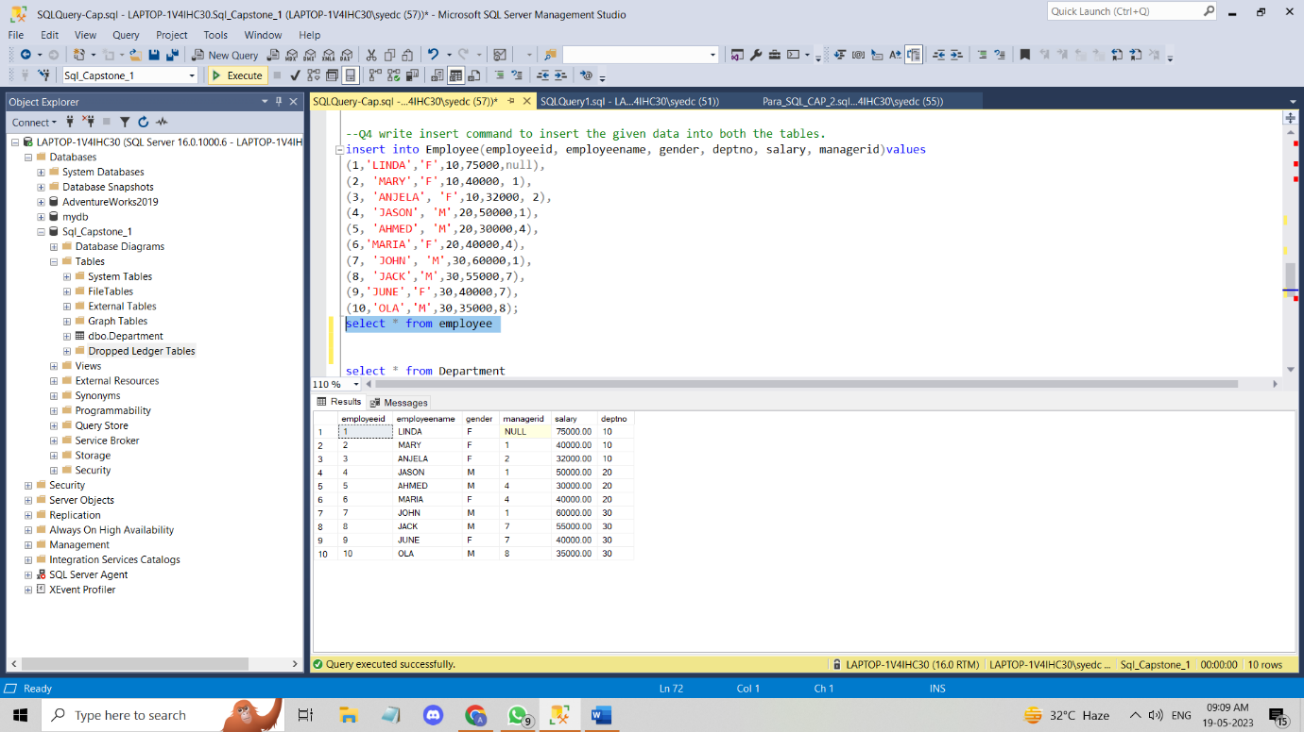

**(5) Write query for following result:**

**(a)to get the employees where first and last character of their name are same.**

**Ans:** select * from Employee where left(employeename,1)=right(employeename,1);

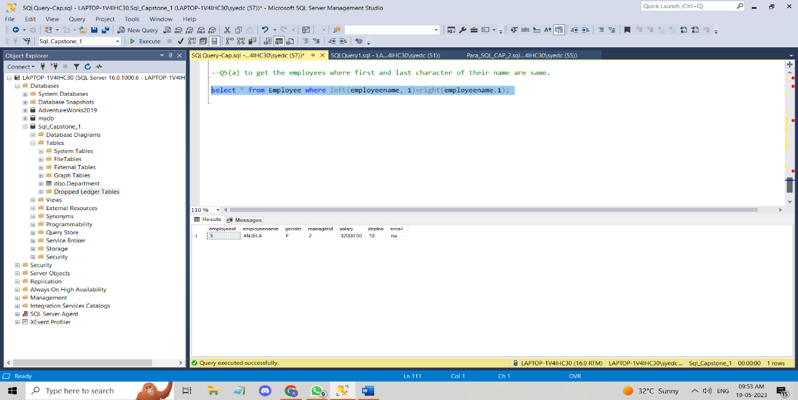

**(b)** **Find employees where the length of name is greater then the length of employee where eid=5.**

**Ans:** Select * from employee where len(employeename)> len(

(select employeename from employee where employeeid=5 ));

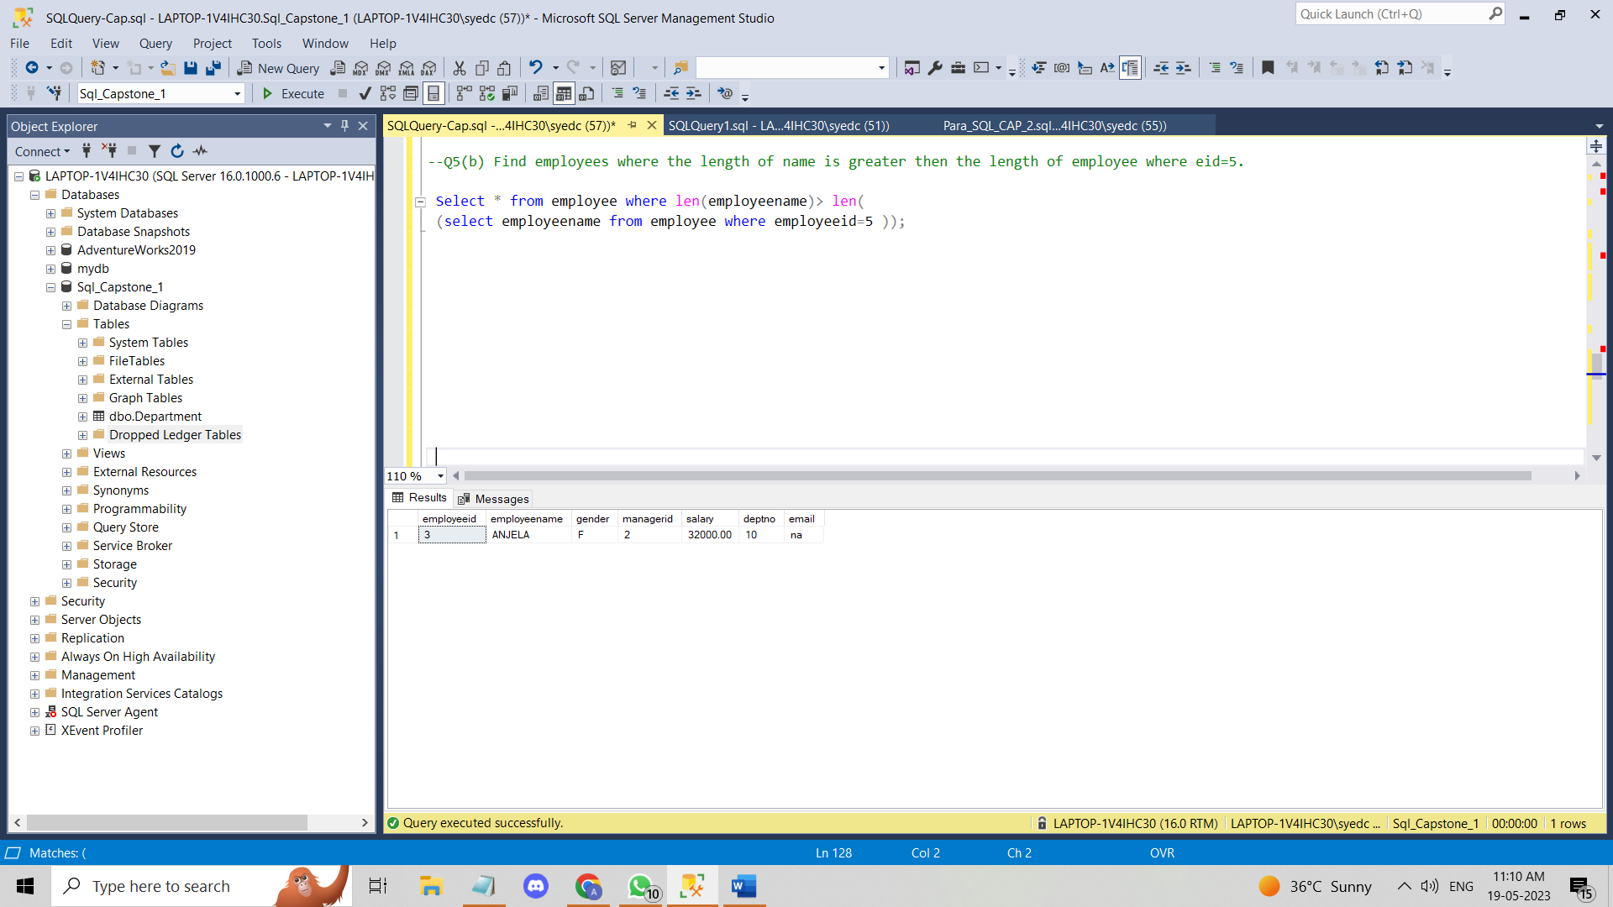

**(c) In the output get all the neame in one row sepearting by comma.**

**Ans:** Select String_agg(Employeename, ',')As All_Names from Employee;

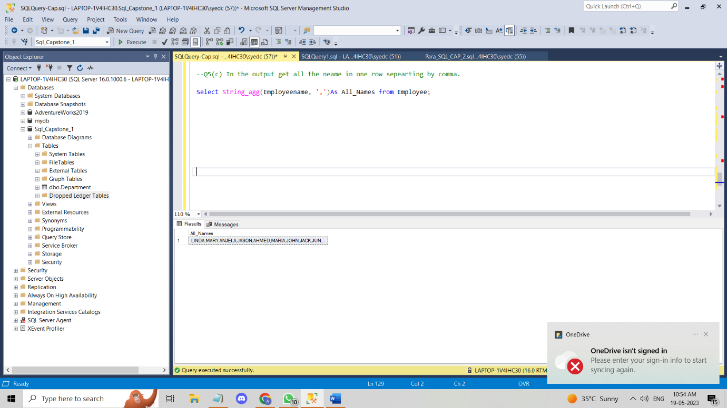

**(d)** **Find the nickname of all employee by putting first and last character of there name together.**

**Ans:** Select Concat(LEFT(Employeename, 1), RIGHT(Employeename, 1)) as Nicknames from employee;

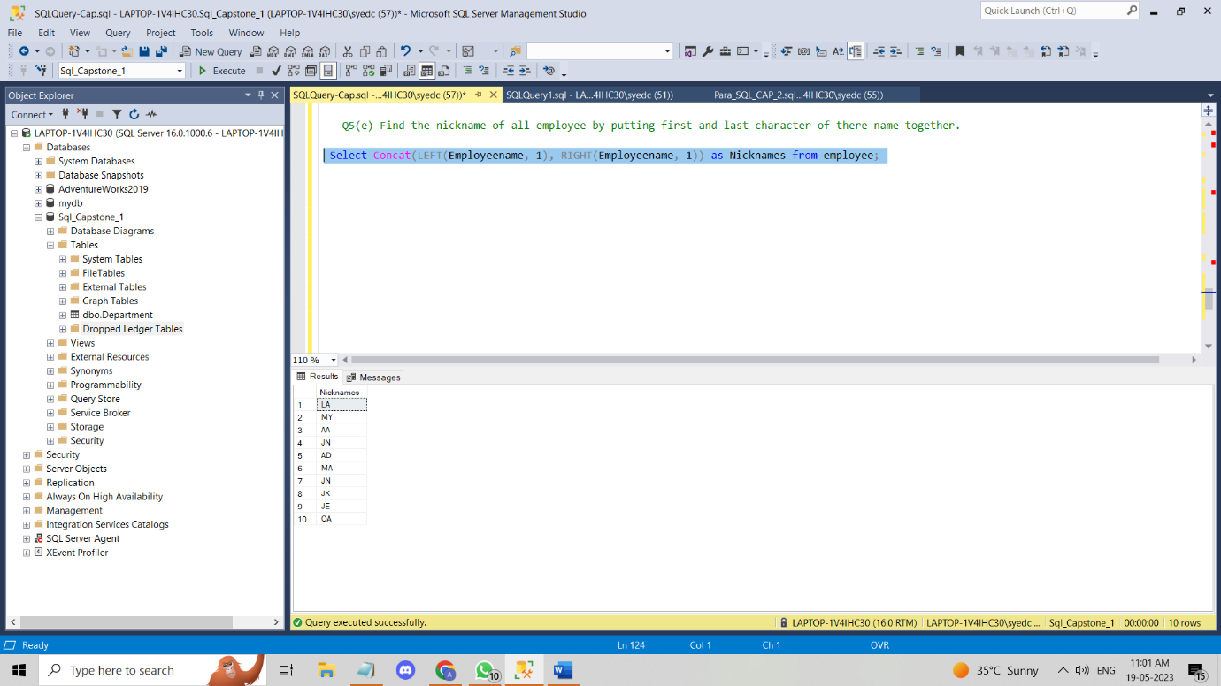

**Q6: write queries to get the following reults:**

**(a) find the count of employee who works in lucknow location.**

**Ans:** SELECT COUNT(employeeid) as No_Of_Employees FROM employee JOIN Department d ON employee.deptno=d.deptno WHERE Location='Lucknow';

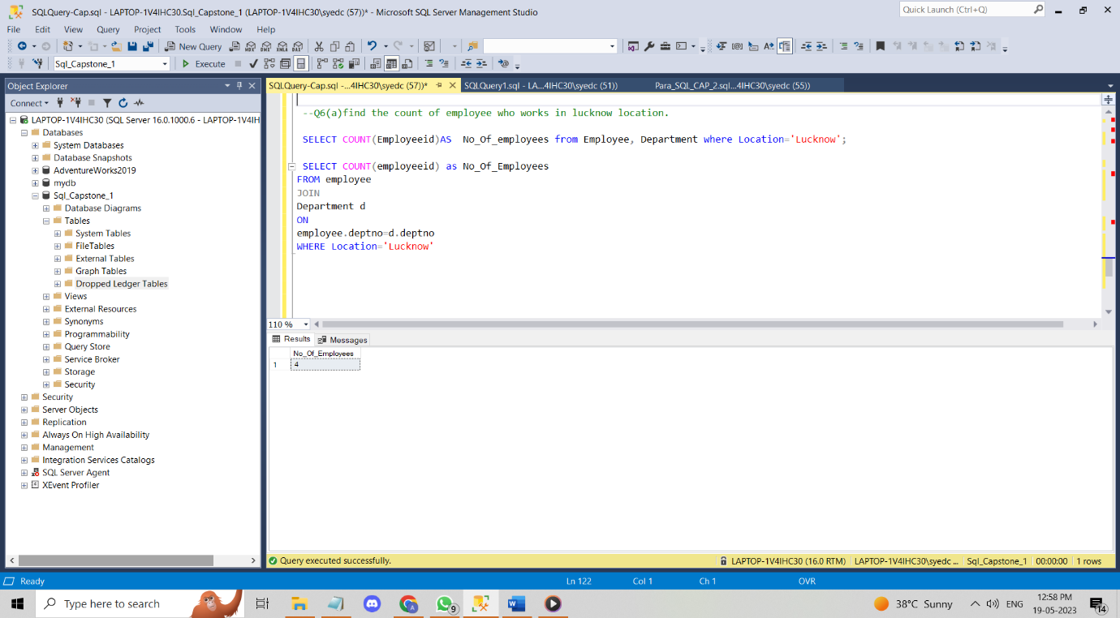

**(b) find the total salary of employees for each deptno.**

**Ans:** Select deptno,Sum(Salary) as Total_Emp_Salary from Employee group by deptno;

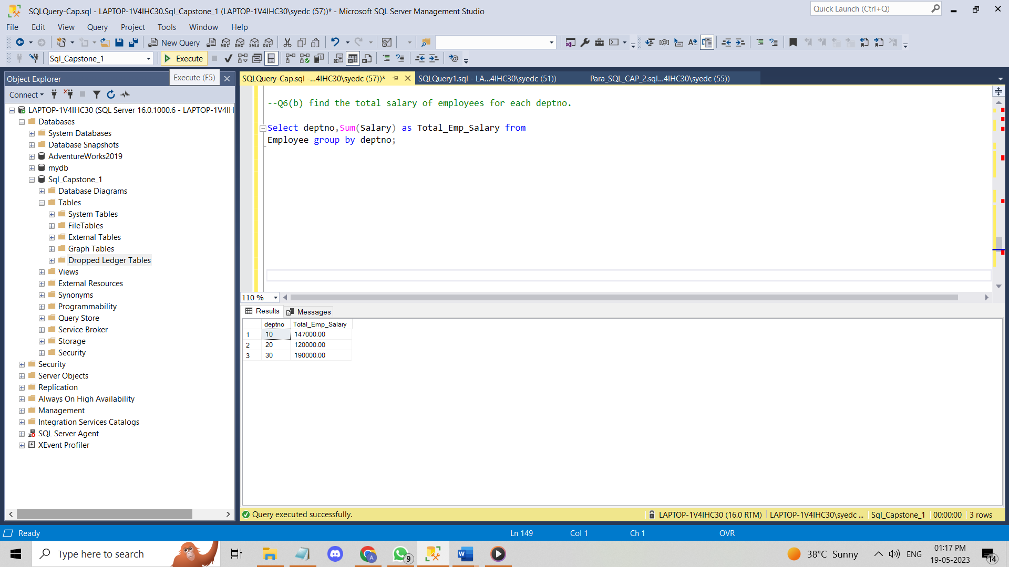

**(c) Find the least and maximum salried employee for each department.**

**Ans:** Select Max(salary)as max_salary, Min(salary) as least_salary,deptname from employee e join Department d ON e.deptno=d.deptno group by deptname;

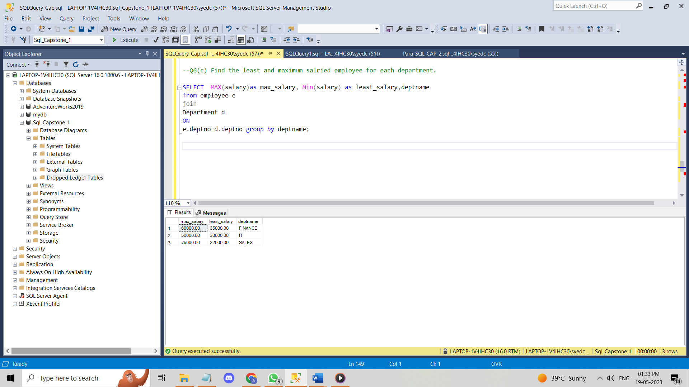

**(d) what is the total salary for male and female employee.**

**Ans:** Select gender as Gen_Emp, Sum(salary) as Total_Salary from Employee GROUP BY Gender;

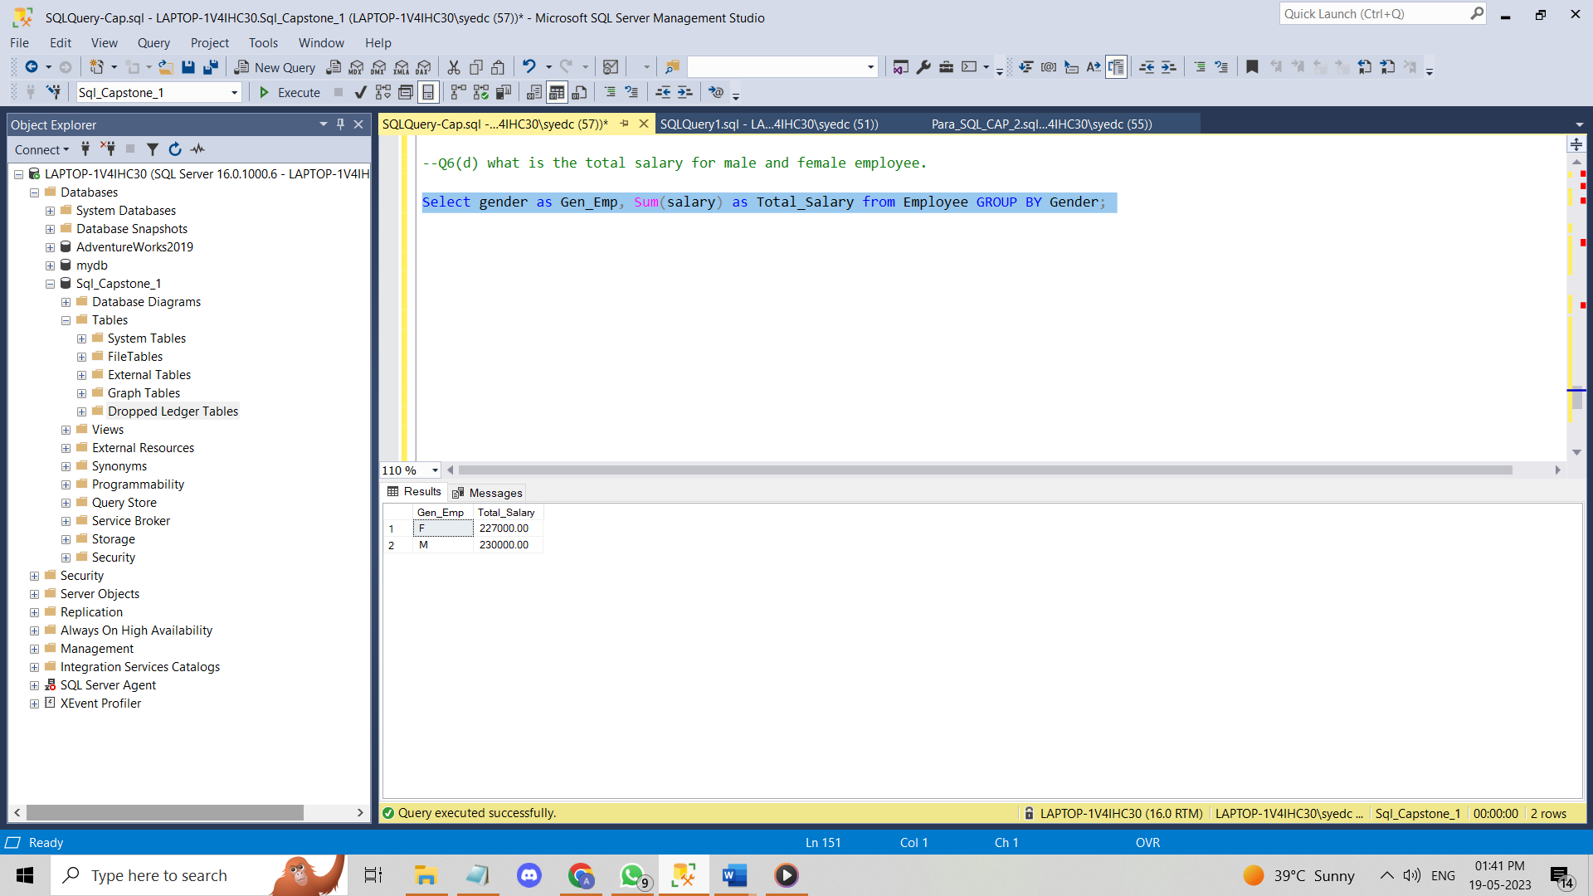

**(e) how many employee get the salary greater then the average salary of marketing department.**

**Ans:** select employeeid, deptno, Avg(salary) as avg_salary from Employee group by employeeid, deptno, salary having salary > (select Avg(salary) as Avg_salary from Employee);

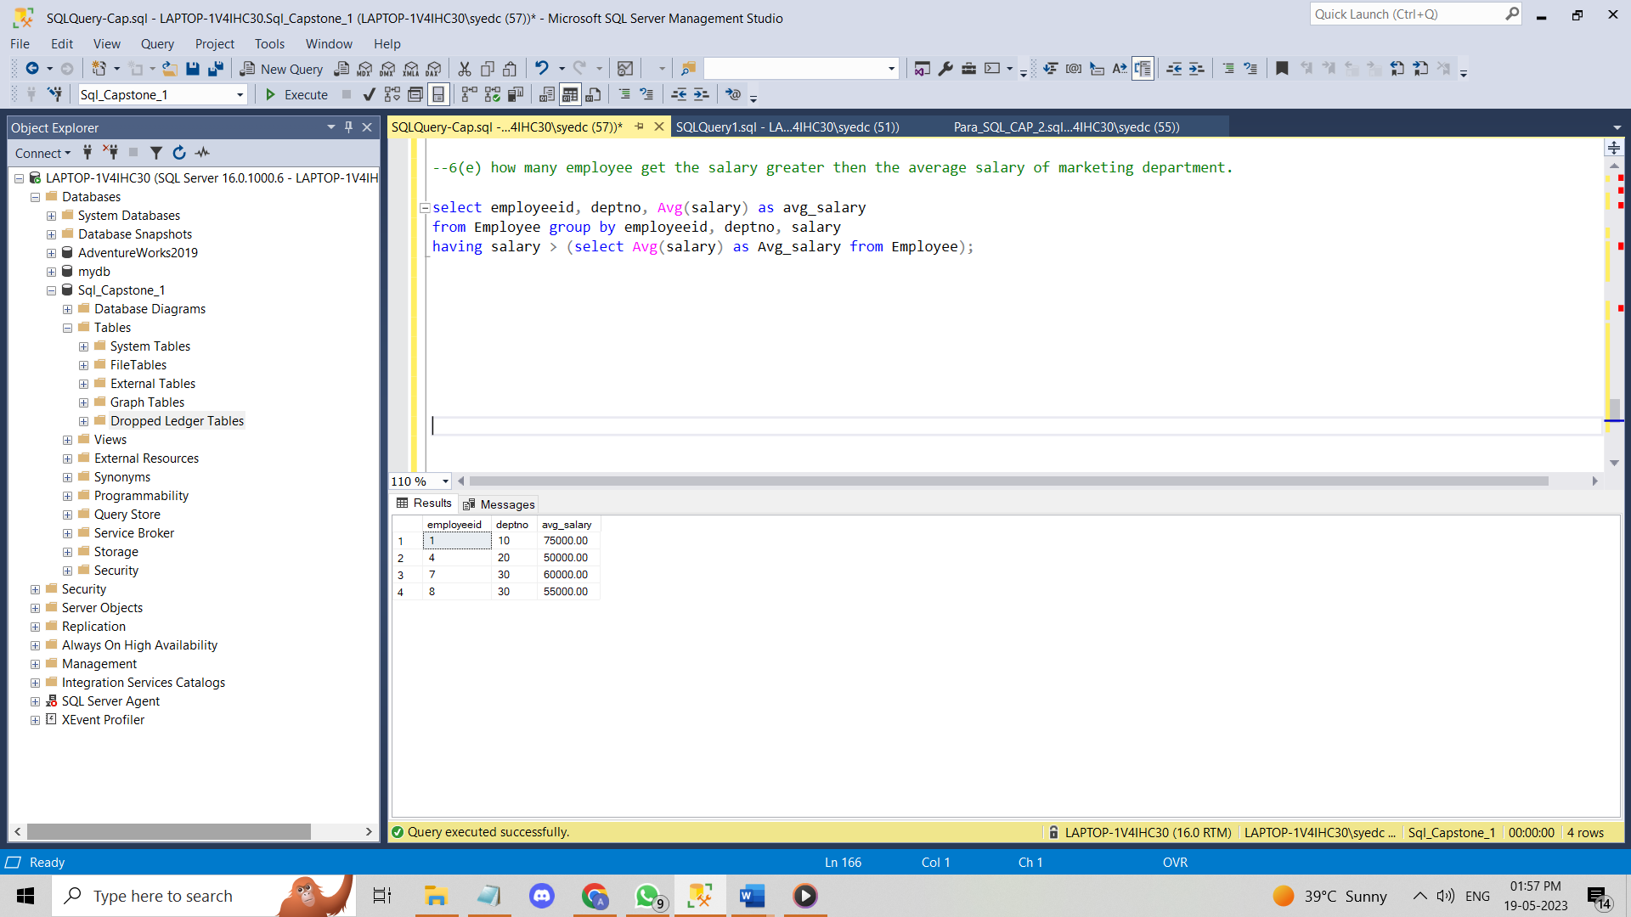

**(F) which department have more number of employees then the employees in finance department.**

**Ans:** SELECT Deptname, COUNT(employeeid) As 'Employee_count' FROM Department JOIN Employee

ON Employee.Deptno = Department.Deptno WHERE deptname='Finance' GROUP BY Department.Deptname

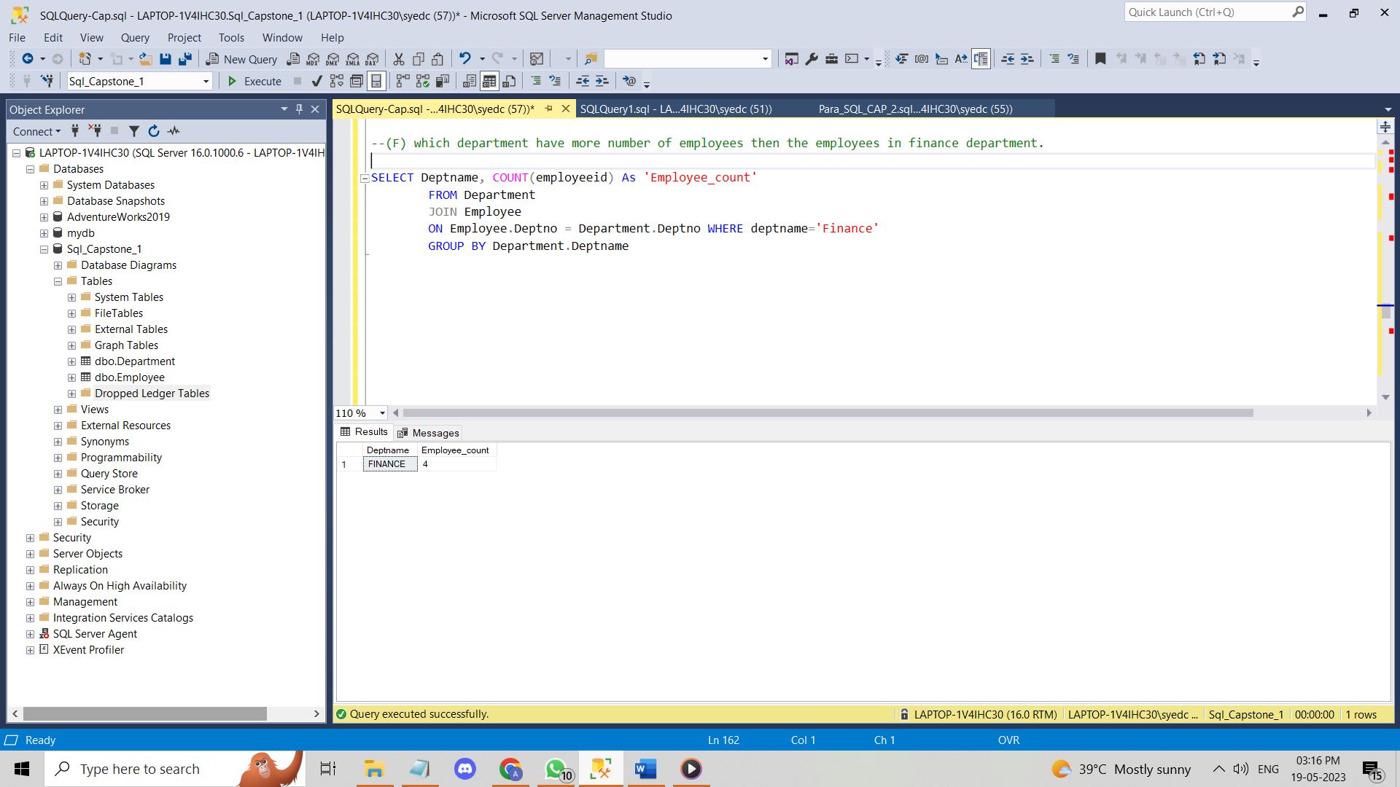

**(7) what are the date function you know?**

**Ans: These are the date functions that I have used during practice.**

|  |  |
| --- | --- |
| DAY (date or datetime) | Returns the day of the week for a given date |
| MONTH (date or datetime) | Returns the month of a given date |
| YEAR (date or datetime) | Returns the year of a given date |
| DATEPART (date part, date or datetime) | Returns the date part specified in int format |
| DATENAME (date part, date or datetime) | Returns the date part specified in character format |
| EOMONTH (date [,months to add) | Returns the last do of the month with an optional parameter to add months (+ or -). |
| DATEADD (date part, units, date or datetime) | Return date math results |
| DATEDIFF (date part, start date, end date) | Give the difference between 2 dates in units specified by date part |

**(8)(a)** **create table Sales(SID int primary key,sales money,sdate date,EID int)**

**Ans:** create table Sales(Sid int,sales money,sdate date,EID int);

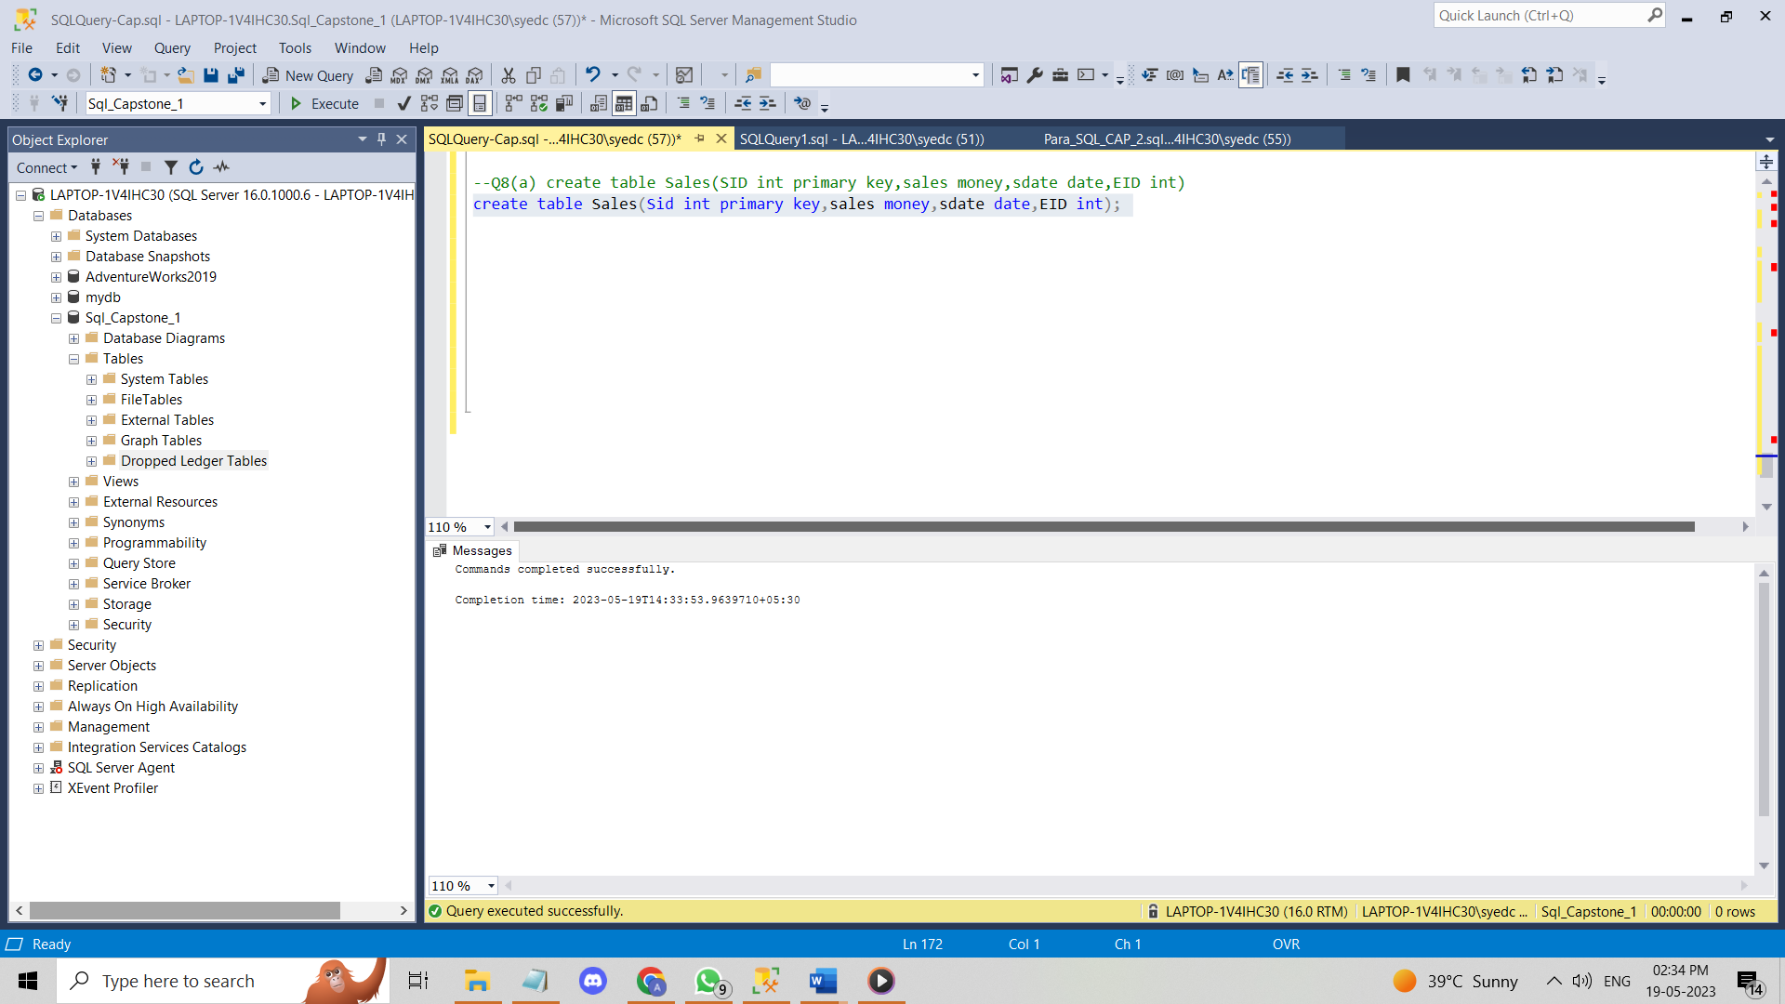

**(b)** **After table is created, add Primary key on SID and foreign key on EID. This EID should reference Employee table primary key**

**Ans:** Alter table Sales add primary key(sid);

Alter table sales add foreign key(Eid) references employee(employeeid);

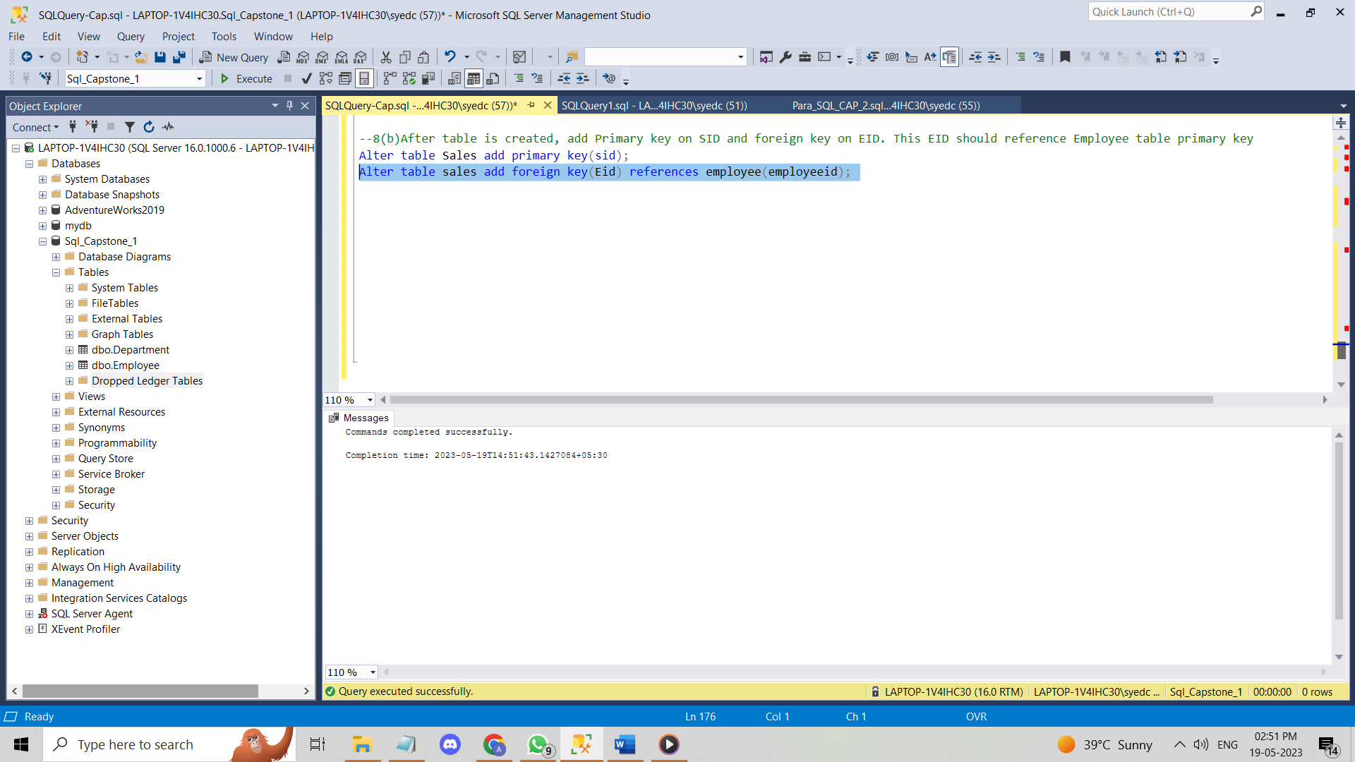

**(c)** **Insert the records:**

**Ans:** INSERT INTO Sales VALUES

(101,4000,'2005-10-10',1),

(102,2300,'2006-01-12',1),

(103,9000,'2005-06-20',2),

(104,4500,'2007-02-10',2),

(105,3200,'2007-02-27',3),

(106,2100,'2008-05-25',3),

(107,6200,'2008-04-14',4),

(108,1900,'2009-10-24',4),

(109,9100,'2009-03-20',5),

(110,7600,'2010-12-12',5),

(111,8300,'2010-09-15',6),

(112,4800,'2010-06-23',6),

(113,3900,'2010-08-10',7),

(114,8100,'2010-11-14',7),

(115,4900,'2011-10-19',8),

(116,5000,'2011-04-20',8),

(117,8400,'2011-05-24',8),

(118,2700,'2011-10-12',9),

(119,7100,'2012-08-20',9),

(120,4100,'2012-03-15',9),

(121,2100,'2012-03-15',10),

(122,9300,'2012-09-15',10),

(123,9200,'2013-07-15',11),

(124,8300,'2013-03-15',11);

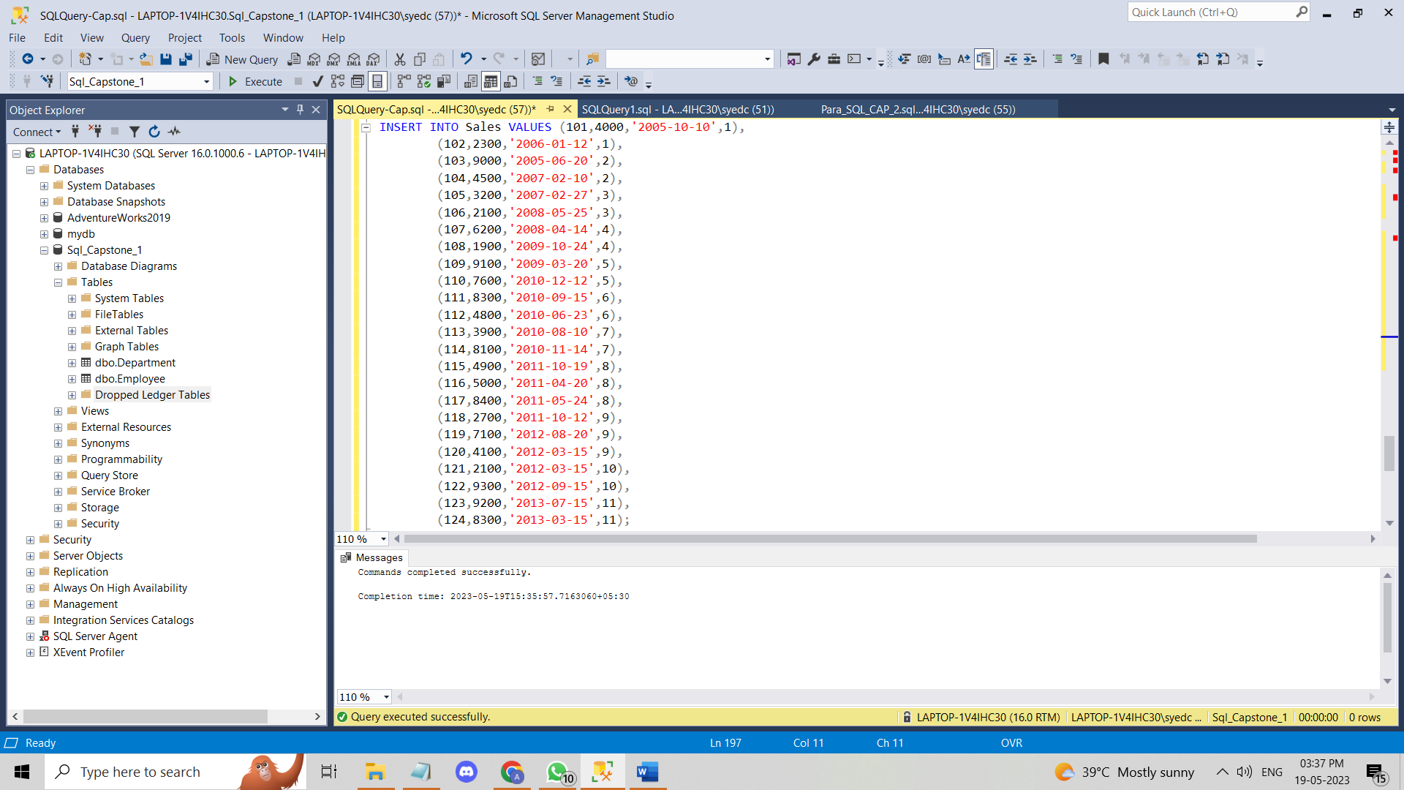

**(9)(a). Display dname,ename,salary for top 2 employees salary wise only for IT department. Use ranking function**

**Ans:**

select top 2 salary ,employeename as ename, RANK() OVER (ORDER BY salary desc) salary_rank, deptname as dname from employee e inner join

Department d on e.deptno=d.deptno where Deptname='IT';

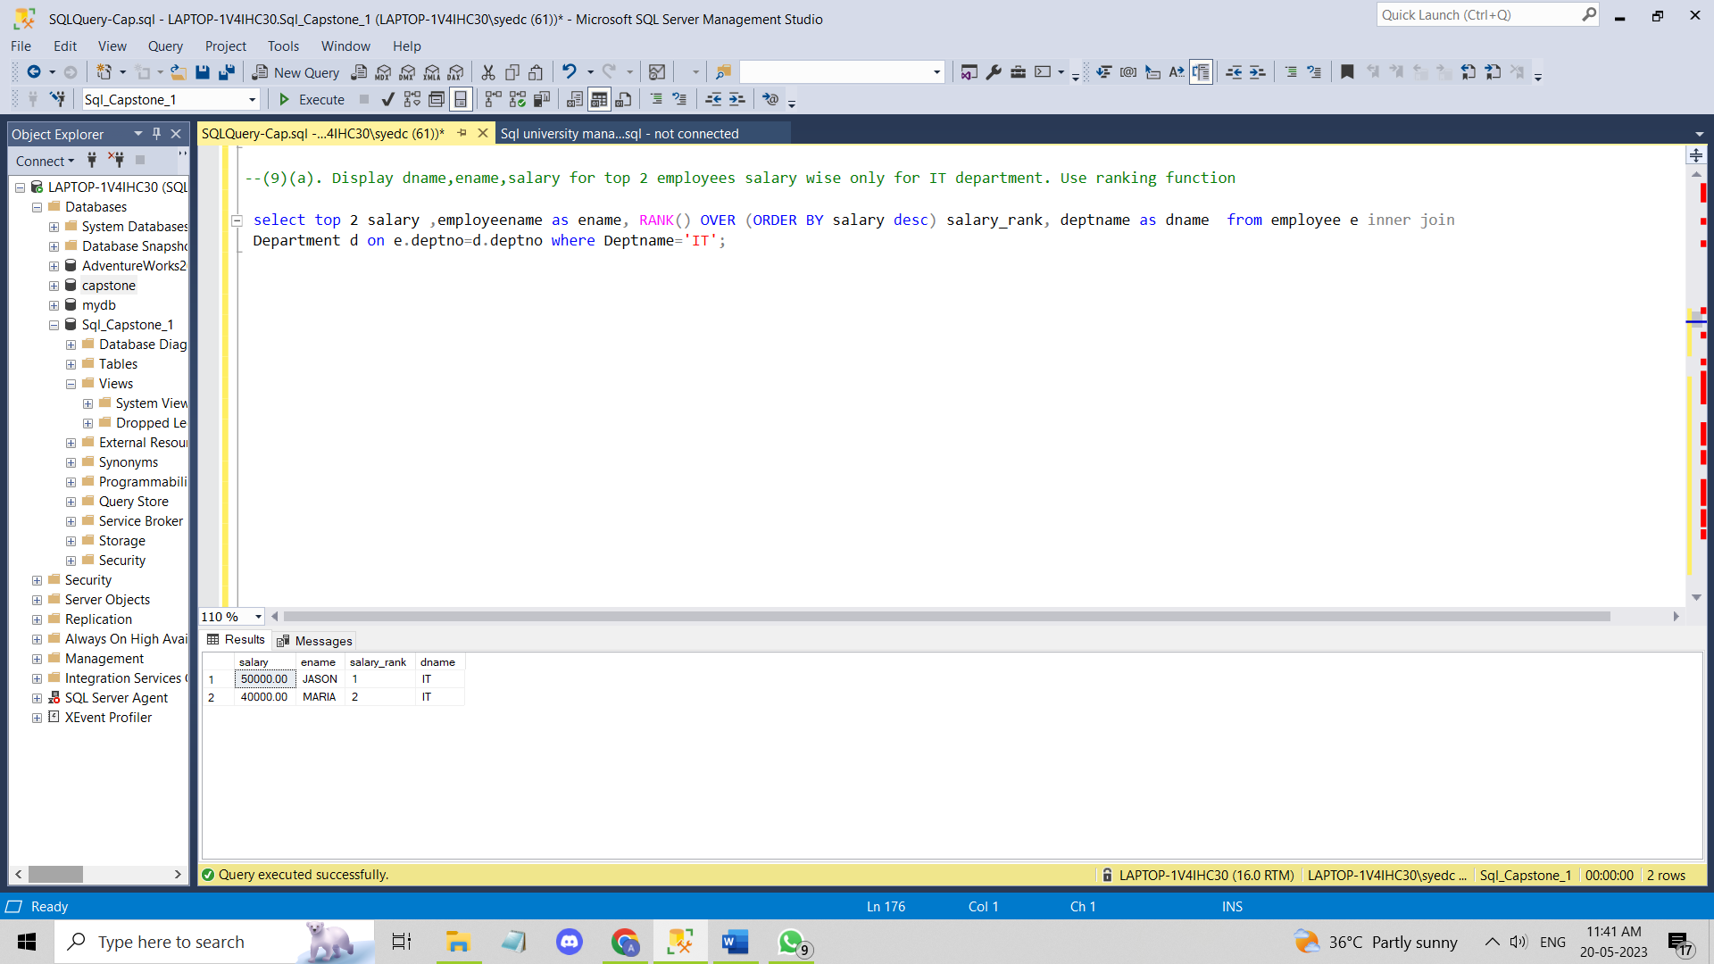

**(b). Display top 2 salaried employees from every department. Show Dname, Ename and Salary**

**Ans:** select top 2 salary ,employeename as ename, deptname as dname from employee e inner join

Department d on e.deptno=d.deptno group by deptname, salary, employeename;

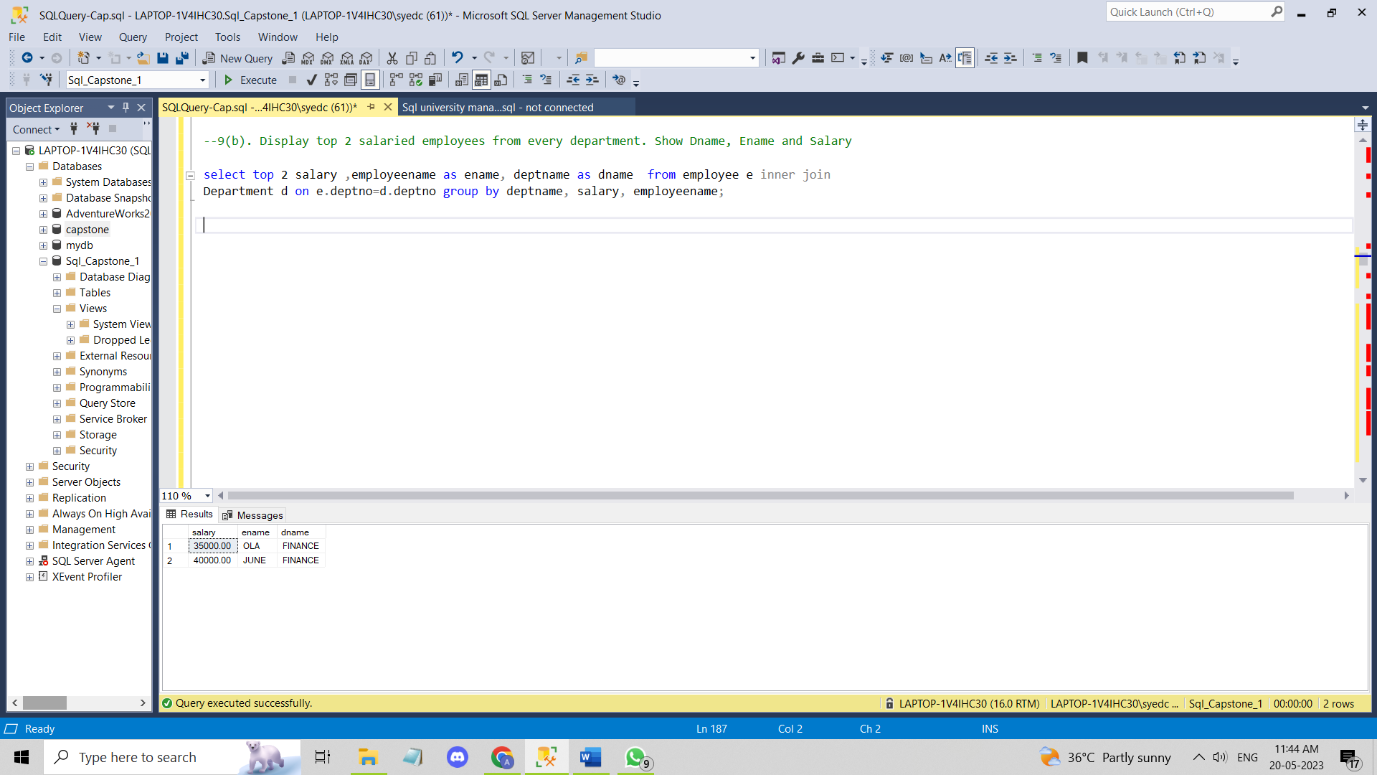

**(c). Display the department name and total sales done by those department.**

**Ans:** select deptname, Sum(sales) as Total_sales from Department d join

Sales s on d.deptno=s.Employeeid group by deptname;

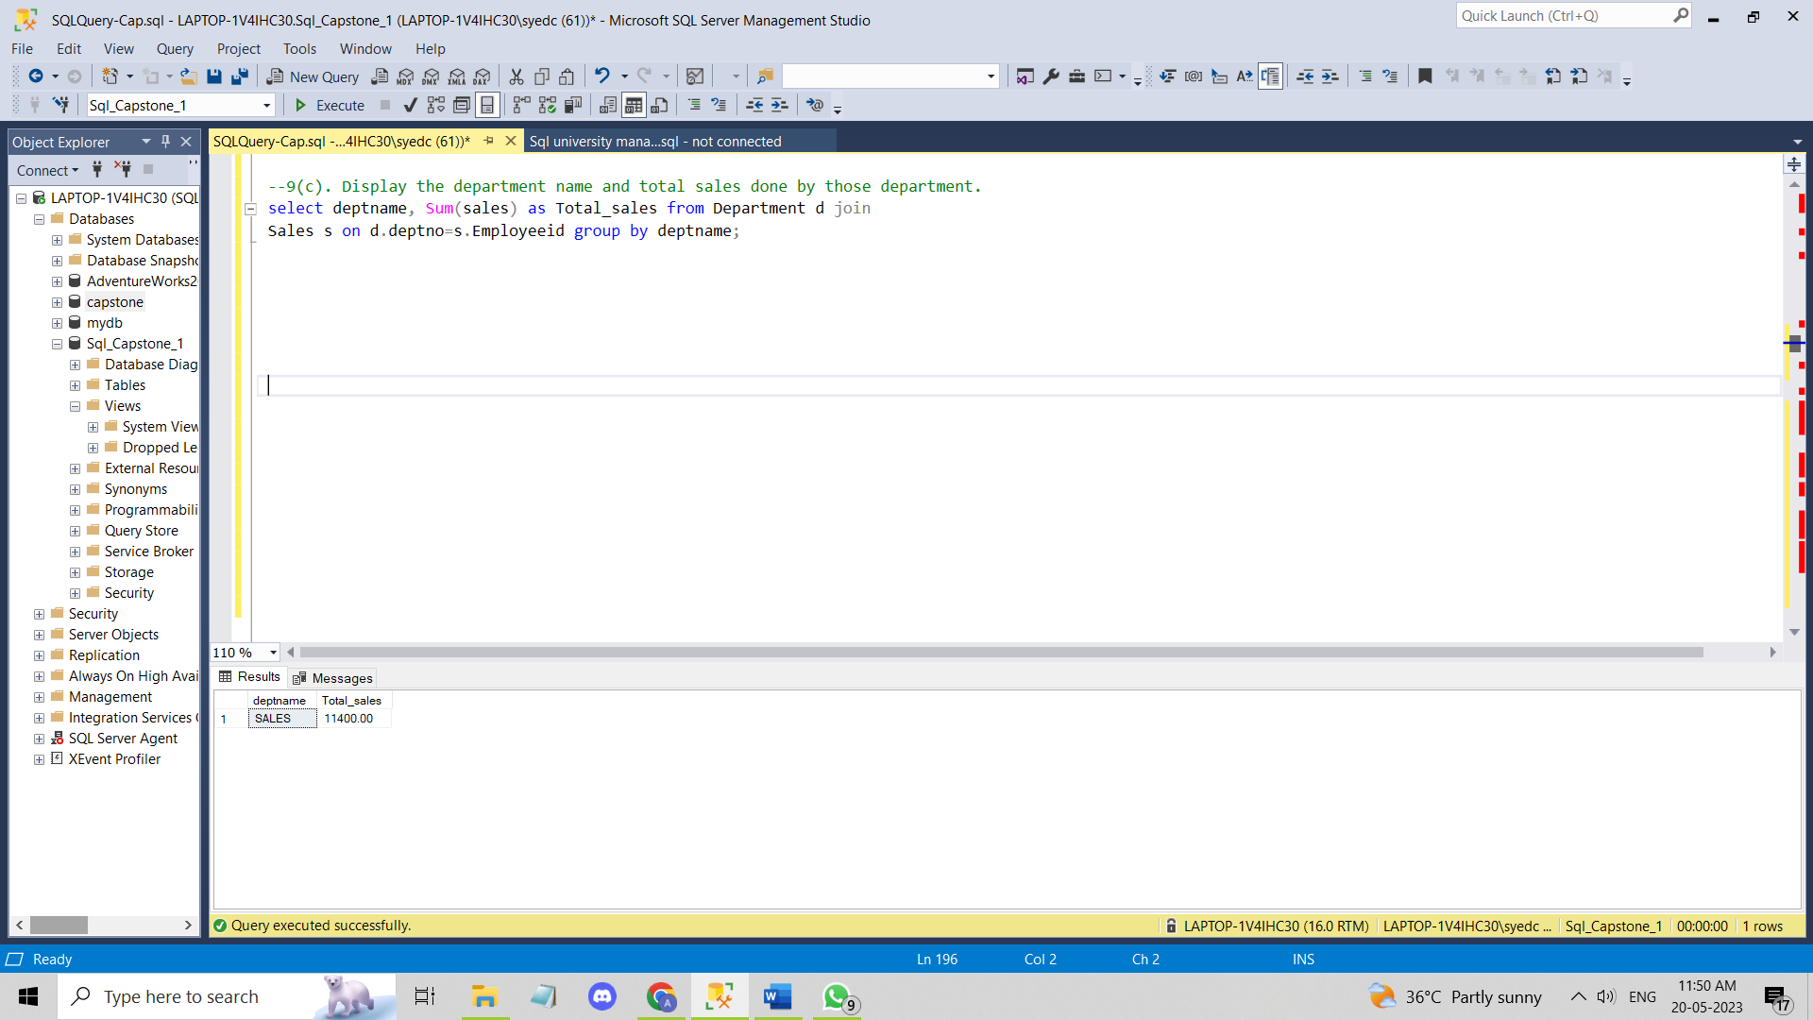

**(d).Display the name and sales for those employees who do sales in October**

**Ans:** select employeename as name, sales, sales_Date from employee e join

Sales s on e.employeeid=s.Employeeid where sales_Date in 'october'

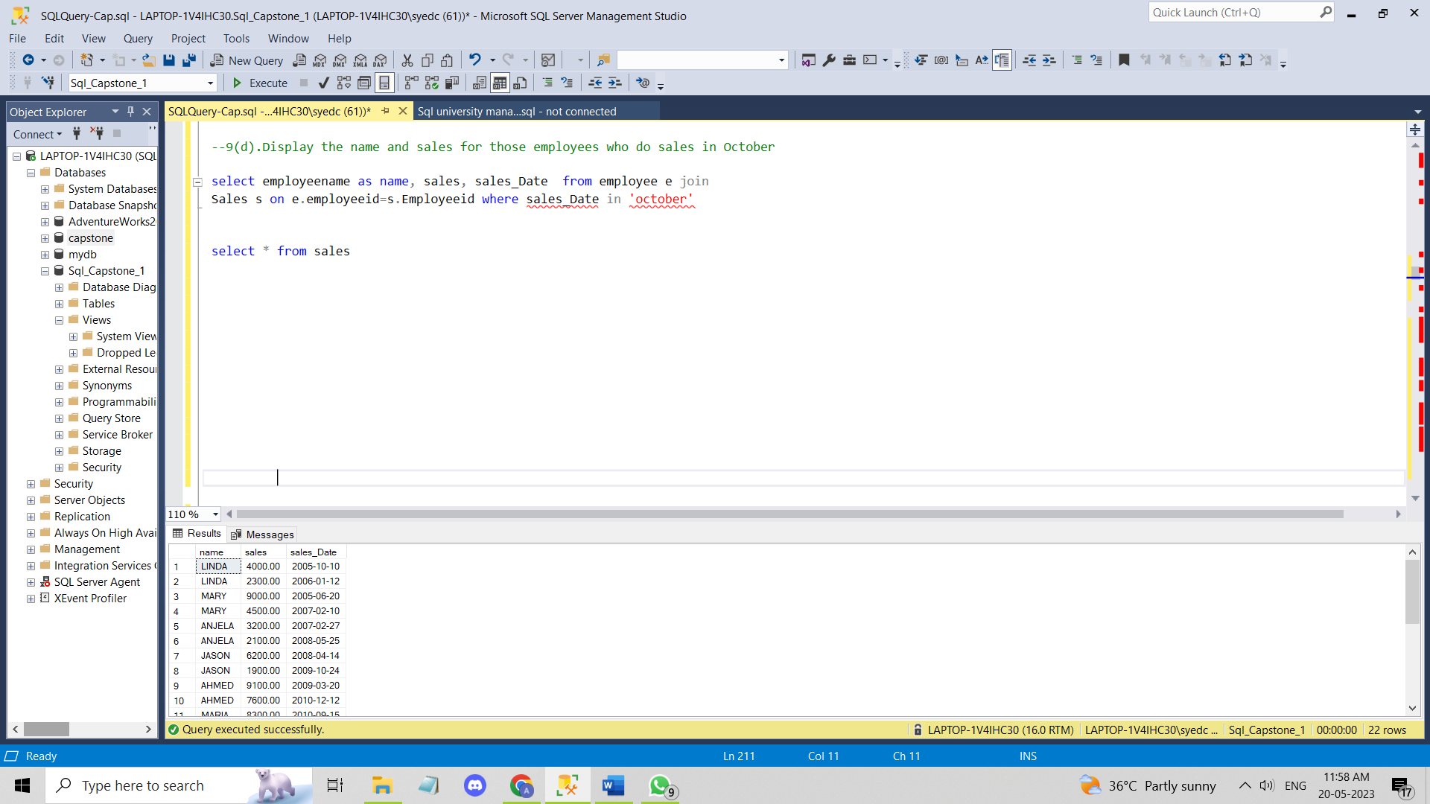

**(e). Display the name and manager name of all the employees including the name of Top level employee**

**Ans:**

(**10)(a). Find employees who have not done any sales.**

**Ans:**

select e.employeename from employee e

join sales s on e.employeeid=s.Employeeid

where s.Employeeid = null;

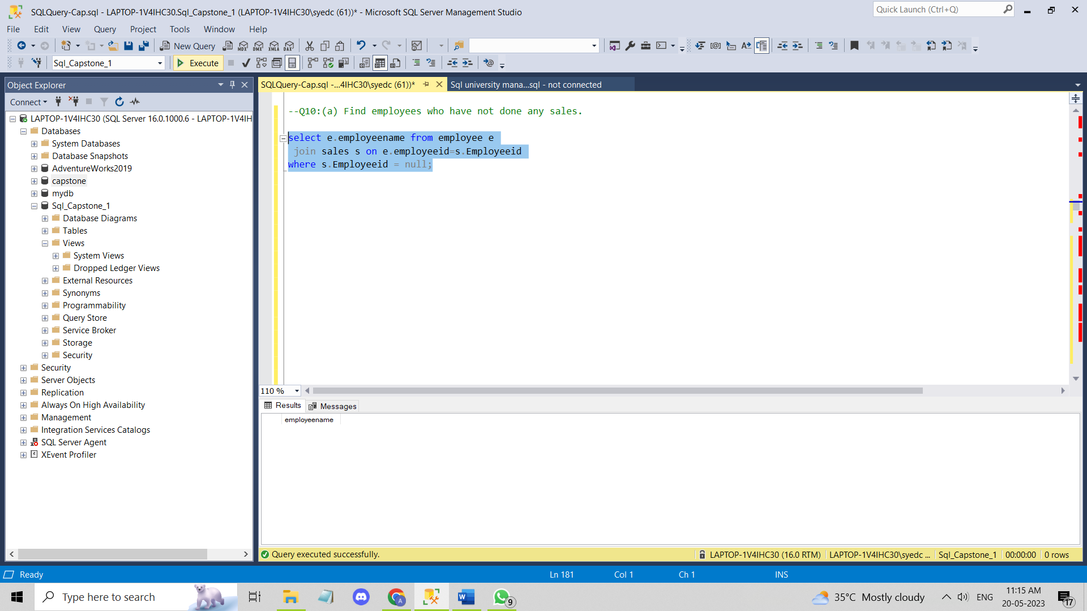

**(b). Find employee who have done more number of sales then the employee who have done 2 nd maximum total sale out of all employees.**

**Ans:**

**Q11:create view so that column included are employeename,deptname,salary,location. This view should be schemabinded and encrypted.**

**Ans:** create view dbo.Empview with Schemabinding,Encryption As

select e.employeename , d.deptname, e.salary, d.location from

dbo.Employee e

Join dbo.department d On e.deptno=d.deptno;

